
AXI – UART COMMUNICATION SYSTEM


November 2, 2025
mirafra technology

Chapter 1 | Introduction
Chapter 2 | Architecture
Chapter 3 | Testbench Components
Chapter 4 | Design Bugs
Chapter 5 | Coverage & Assertions
Chapter 6 | Output
Chapter 7 | Conclusion
Contents

CHAPTER – 1
- Introduction
- The AXI Stream to UART system transfers parallel data from an AXI-Stream interface to a UART serial channel.
- Data send by the AXI-Stream master is pushed into a synchronous FIFO buffer. The FIFO output is then serialized and transmitted by the UART transmitter.
- On the receiver side, the UART receiver deserializes the data, checks parity, and outputs parallel data.

  - Functionality

Module | Function
AXIS Master Input | sends valid data packets for transmission using AXI Stream handshaking signals (valid, ready, last).
Synchronous FIFO | Buffers AXI Stream data to handle speed differences between producer (AXIS Master) and consumer (UART TX). Supports parallel read/write operations and “full/empty” detection.
UART Transmitter | Converts parallel FIFO data into serial format as per configured baud rate. Supports even parity generation.
UART Receiver | Deserializes received UART stream, reconstructs parallel data, verifies parity, and asserts rx_valid when data is ready and parity is verified.

  - Operating Sequence
- AXI Input Stage: AXI master asserts axis_valid with data on axis_data. When m_axis_ready is high, data is accepted and written to FIFO.
- FIFO Buffering: FIFO stores incoming bytes until the UART transmitter is ready to send. Read and write can occur simultaneously.
- UART Transmission:
- Each byte is serialized at 115200 baud.
- Start bit (0), data bits (8), parity bit, and stop bit (1) are sent.
- tx_data_ready indicates when UART can accept new data.
- UART Reception:
- Receiver detects start bit, samples bits at mid-baud intervals.
- Extracts data, verifies parity, and asserts rx_valid.

  - Design Parameters
Parameter | Value
Data Bits | 8 bits per UART frame
Baud Rate | 115200
Clock Frequency | 50 Mhz
FIFO Depth | 8 bytes
  - UART Frame Format

Parity bit bbbitbtBit
Start Bit
Data bit
Stop Bit

  - Working
- The project verifies an AXI to UART interface using a UVM-based testbench.
- The DUT converts AXI-stream input data into serial UART transmission and reconstructs it back into parallel output.
- The input signal axis_data carries the 8-bit data from the AXI-stream interface.
- The signal axis_valid indicates when the data on axis_data is valid.
- The signal axis_last goes high to mark the end of a packet once the last data byte has been sent.
- The UART transmitter sends data serially bit by bit through uart_tx.
- Each UART frame consists of 1 start bit, 8 data bits, 1 parity bit, and 1 stop bit.
- The total frame length is 11 bits per byte of data.
- The baud rate used is 115200 bps, which corresponds to 434 clock cycles per bit.
- One full byte transmission requires 4774 clock cycles (11 × 434).
- Every 434 clock cycles, one bit of data is transmitted on the uart_tx line.
- The UART receiver samples the uart_tx line and reconstructs the original 8-bit parallel data.
- The receiver removes the start, parity, and stop bits, retaining only the data bits.
- After 4774 clock cycles, one complete byte of data appears at rx_data.
- The signal rx_valid goes high when valid parallel data is available.
- The signal m_axis_ready indicates the readiness of the receiver FIFO to accept data.
- When m_axis_ready is 1, the FIFO has space and can accept more data.
- When m_axis_ready is 0, the FIFO is full and cannot accept new data.
- A comparison is made between rx_data (parallel output) and the reconstructed serial data from uart_tx.
- If both values match, the data transmission is verified as correct.
- When data matches, rx_valid is asserted high to indicate successful reception.
- The testbench monitors and verifies data integrity, timing, and control signal behavior throughout the communication process.

CHAPTER -2
- Architecture
  - Design Architecture
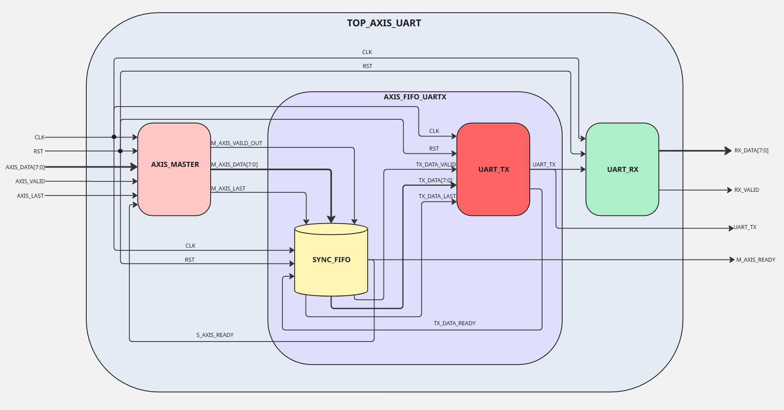

  - Testbench Architecture
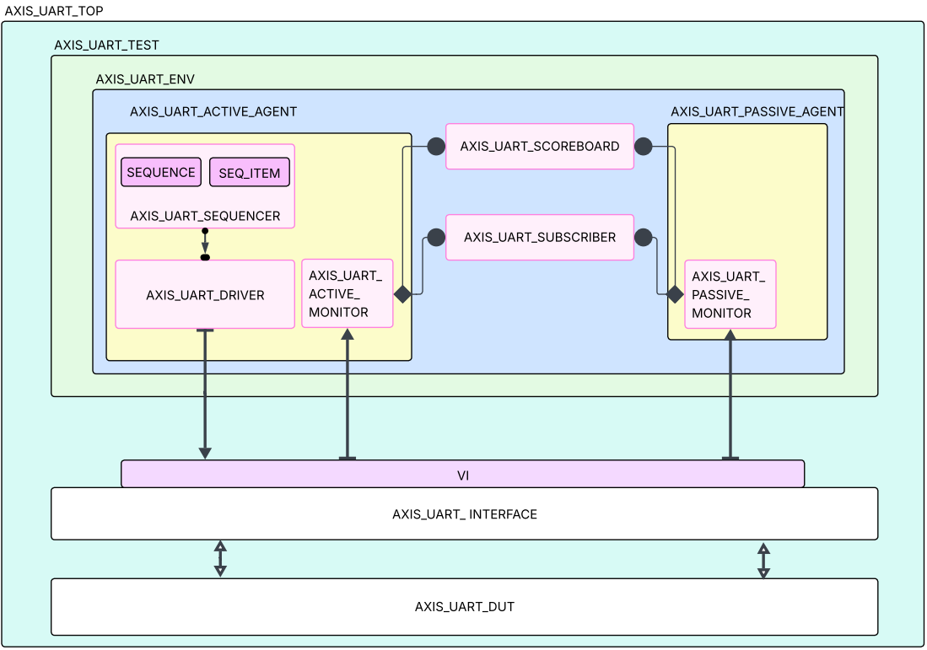

  - Interface Signals

Pin Name | Direction | Width | Function
clk | Input | 1 | Clock Signal
rst | Input | 1 | Active High Synchronous Reset
axis_data | Input | 8 | Parallel input data from AXI Stream master
axis_valid | Input | 1 | AXI Stream valid signal – indicates valid data for axis_data
axis_last | Input | 1 | Indicates last data in a frame
m_axis_ready | Output | 1 | Indicates that system is ready to accept new AXI data i.e. the FIFO is not full.
uart_tx | Output | 1 | UART serial transmit line
rx_valid | Output | 1 | High for one clock cycle when new data is received successfully
rx_data | Output | 8 | Parallel data after UART reception

CHAPTER – 3
- Testbench Components
- axi_uart_interface.sv
  - Defines the connection between the DUT and the UVM testbench.
  - Includes signals like axis_data, axis_valid, axis_last, uart_tx, rx_valid, rx_data, and m_axis_ready.
  - Contains clocking blocks for driver and monitor synchronization.
  - Provides modports for active and passive agents to interact with the DUT.
- axi_uart_seq_item.sv
  - Defines the transaction class that represents a single unit of data transfer.
  - Includes fields such as axis_data, axis_valid, axis_last, rx_data, rx_valid, and uart_tx.
  - Used as a communication object between the driver, sequencer, and monitors.
- axi_uart_sequence.sv
  - Generates a sequence of transaction items (axi_uart_seq_item).
  - Randomizes data to simulate multiple data packets being sent to the DUT.
  - Controls the number of packets to send using a repeat loop or global variable.
- axi_uart_sequencer.sv
  - Acts as a bridge between the sequence and the driver.
  - Sends transactions from the sequence to the driver for execution.
  - Synchronizes the flow of data items during simulation.
- axi_uart_driver.sv
  - Drives the AXI input signals (axis_data, axis_valid, axis_last) to the DUT using the virtual interface.
  - Receives sequence items from the sequencer and applies them to the DUT.
  - Ensures timing correctness and data validity on the AXI interface.
- axi_uart_active_monitor.sv
  - Monitors the DUT’s input (AXI side) interface.
  - Samples axis_data, axis_valid, axis_last, and m_axis_ready signals.
  - Sends observed transactions to the scoreboard and subscriber through an analysis port.
  - Verifies that valid data is sent when expected.
- axi_uart_passive_monitor.sv
  - Observes the DUT’s output (UART side).
  - Samples uart_tx every 434 clock cycles to reconstruct the serial data.
  - After 4774 clock cycles, produces one byte of received data (rx_data).
  - Sends the monitored data to the scoreboard for comparison with expected results.
- axi_uart_active_agent.sv
  - Contains the active components: driver, sequencer, and active monitor.
  - Responsible for generating and applying stimulus to the DUT.
  - Operates in UVM_ACTIVE mode to drive signals.
- axi_uart_passive_agent.sv
  - Contains only the passive monitor (no driver or sequencer).
  - Operates in UVM_PASSIVE mode to observe DUT outputs.
  - Used to monitor UART response behavior.

- axi_uart_scoreboard.sv
  - Performs data checking and result verification.
  - Compares transmitted (axis_data) and received (rx_data) values.
  - Uses queues to store expected data and remove entries when matched.
  - Checks parity correctness and FIFO full/empty conditions.
- axi_uart_subscriber.sv
  - Collects functional coverage information from analysis ports.
  - Ensures all scenarios such as valid/invalid data, FIFO full/empty, and parity conditions are covered.
- axi_uart_environment.sv
  - Instantiates and connects all agents, scoreboard, and subscriber.
  - Defines the structure of the entire testbench.
  - Connects analysis ports of monitors to the scoreboard and subscriber.
- axi_uart_test.sv
  - Top-level UVM test class.
  - Creates the environment and runs the main sequence.
  - Raises and drops simulation objections to control phase execution.
  - Optionally applies drain time to allow pending transactions to complete.
- axi_uart_pkg.sv
  - Central package file that includes all other class files.
  - Simplifies compilation by bundling all UVM components together.
  - Allows easy import into the testbench.
- global_pkg.sv
  - Contains global static variables and counters shared across components.
  - Stores variables like count, baud_count, and randomized pkt (packet count).
  - Helps maintain global simulation states accessible throughout the environment

CHAPTER – 4
- Bugs Found
  - Reset condition – BUG1
- While asserting the reset high after few clock cycles, the last 2 bytes of data were only coming and all other data were lost.
- When reset given in the initial clock cycles the DUT was working fine but giving in between caused unexpected behaviour.
  - Sending Stream of Data – BUG2
- While sending the stream of data the last byte of data was always erased.
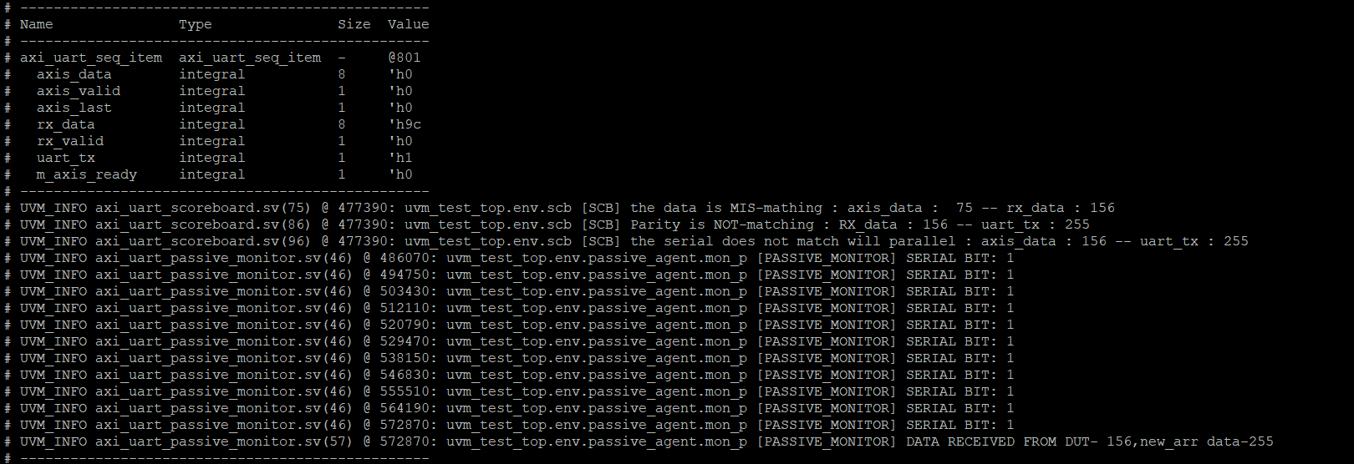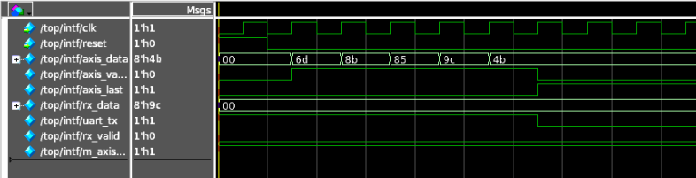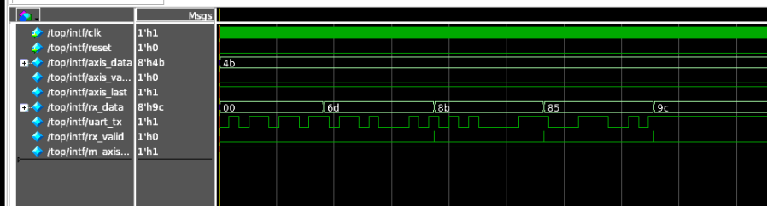

  - Axis_last behaviour – BUG3
- According to the initial specification the axis_last signal should be triggered with the last byte of data, indicating the DUT that no more data will be sent.
- While asserting the axis_last with the last byte of data ,was making us loose the last byte.
- This was reported and the specification was changed mentioning that the asxis_last should be asserted 1 clock cycle after the last byte of data only.
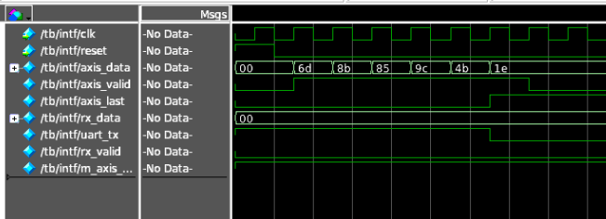
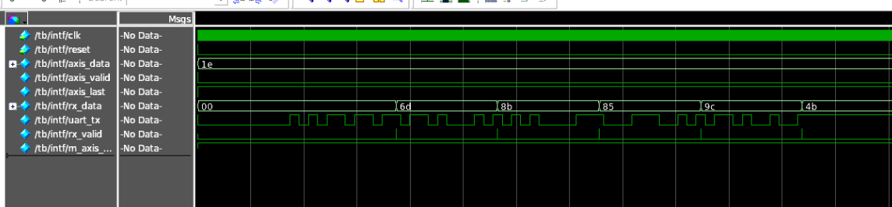
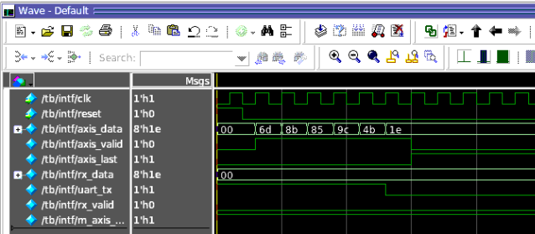

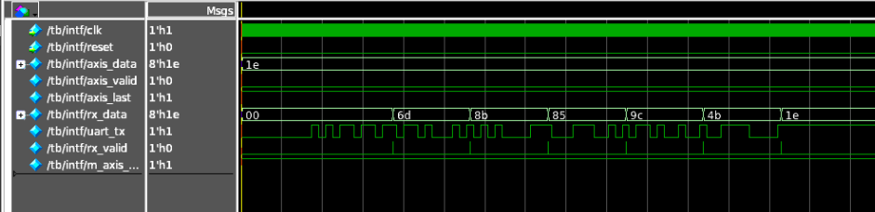
  - Multi Stream of data – BUG4
- After receiving the first stream of data successfully we immediately sent the next stream of data in that case the first 2 byte if next stream were missing.
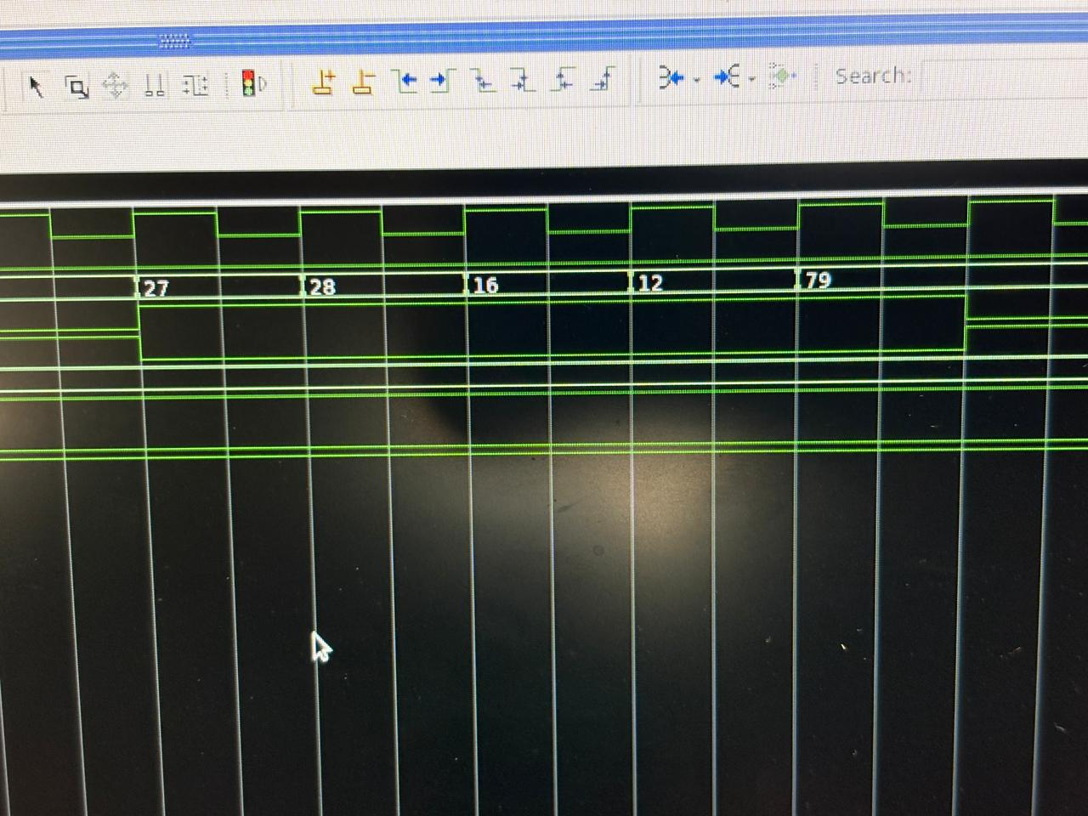
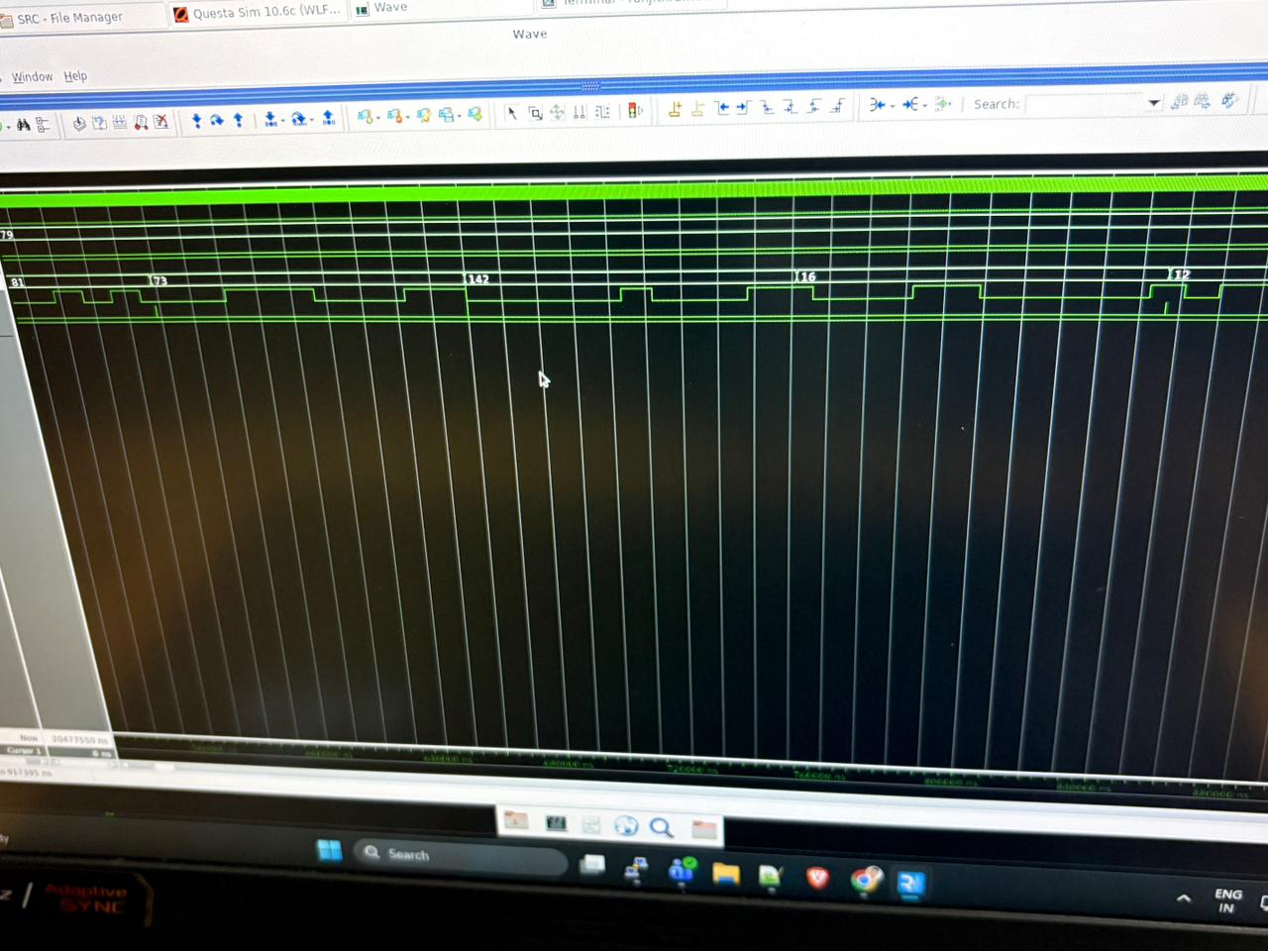

  - RX_VALID triggering missed – BUG5
- While sending the stream of data we have observed that even when the parallel data and serial data are matching the RX valid signal is not triggered high for every first byte of data.
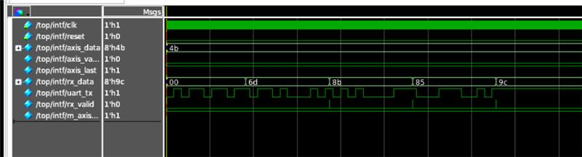

  - RX_VALID triggering for the data we didn’t send – BUG6 (Specification bug)
- In the process of verification we have found out that, only for the output of the first data stream we are getting “0” which was not expected as we have not sent 0 from the driver.
- This bug was issued to the design team they have made a change in the specification specifying that the defaut value for the first transaction will be “0”.
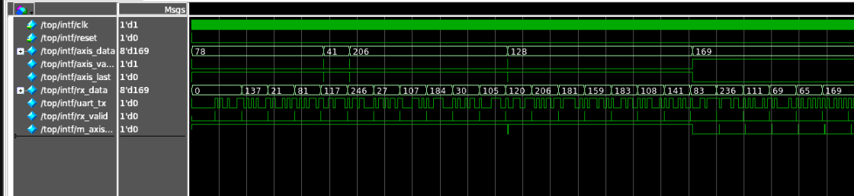

Sl.no | Bug | Description | Status | Type of BUG
1 | Missing of last packet | When N packets are sent,we receive only N-1 packets from DUT,where last data is missed. | Solved | DESIGN
2 | axis_last is not working | According to the specification,axis_last signal which needs to be asserted when the last packet of the stream is sent,but the last packet is not coming out from DUT. | Specification changed | SPECIFICATION
3 | rx_valid is not asserted for first packet | rx_valid which is asserted when the parity of parallel data and serial data are matched,is not getting asserted for the first packet of the stream even when parity is matching | Solved | DESIGN
4 | Junk value from DUT | When multiple stream of packets are sent, if number of packets are greater than fifo size ,everything works fine,but when number of packets are less than fifo size the first stream comes out as expected , but in second stream first 2 packets are lost and instead of that a junk value comes from DUT and then rest 3 packets come out as expected. | Solved | DESIGN
5 | Rx_valid asserting without data | Even when we are sending our first data as 137 with axis_valid , the rx-valid is asserting high for data – 0 which is default in the start this condition has not been mentioned in the spec | Solved | SPECIFICATION
6 | Reset | When asserting the reset after some time the data which is present in the last and first was only coming | Solved | DESIGN

CHAPTER – 5
- DUT coverage
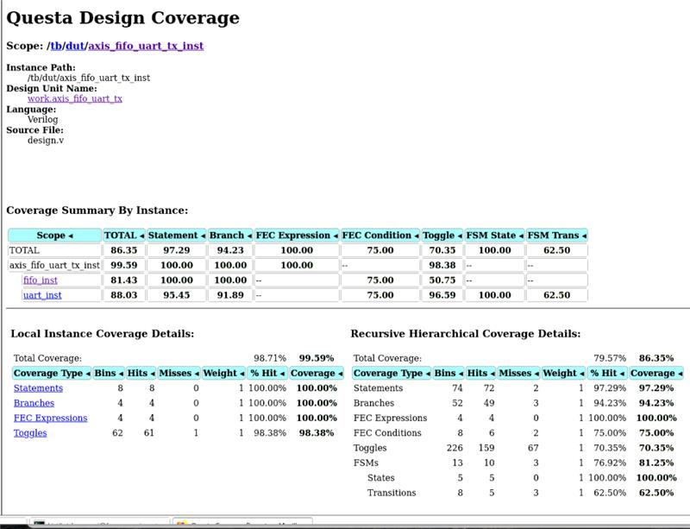

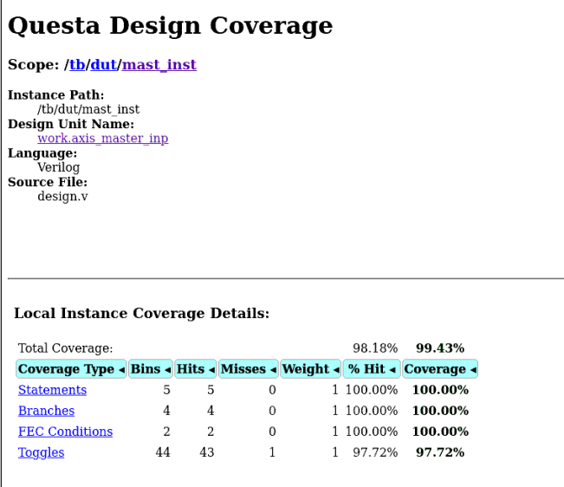
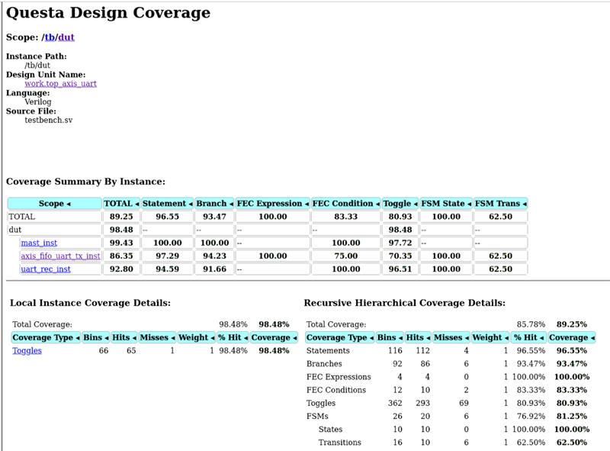
  - Functional Coverage
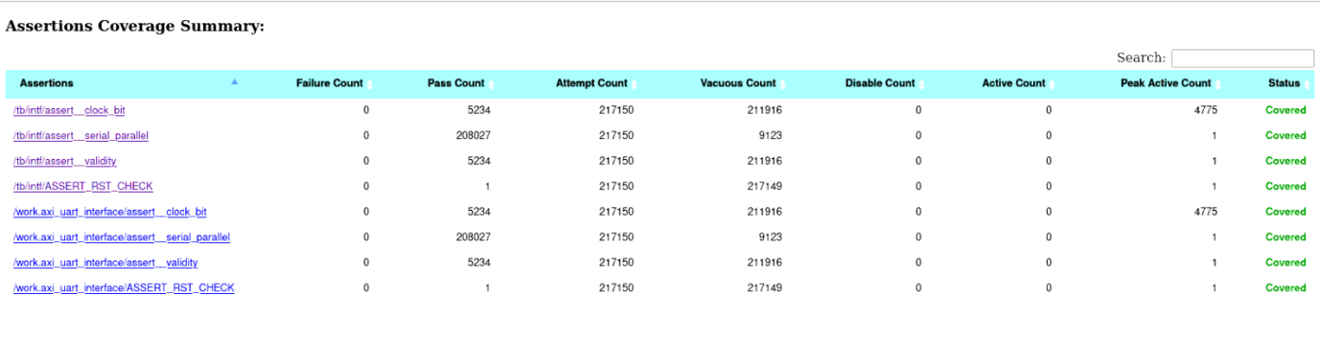
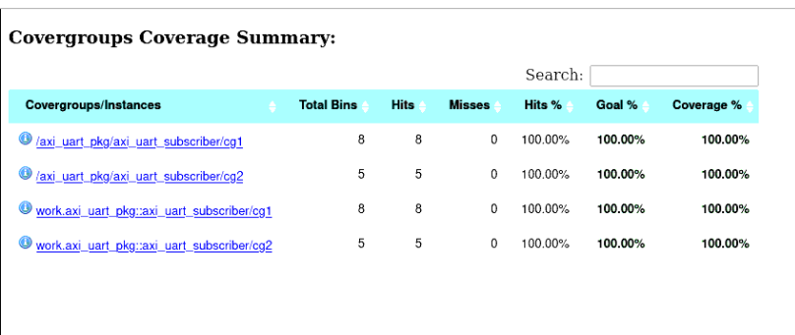
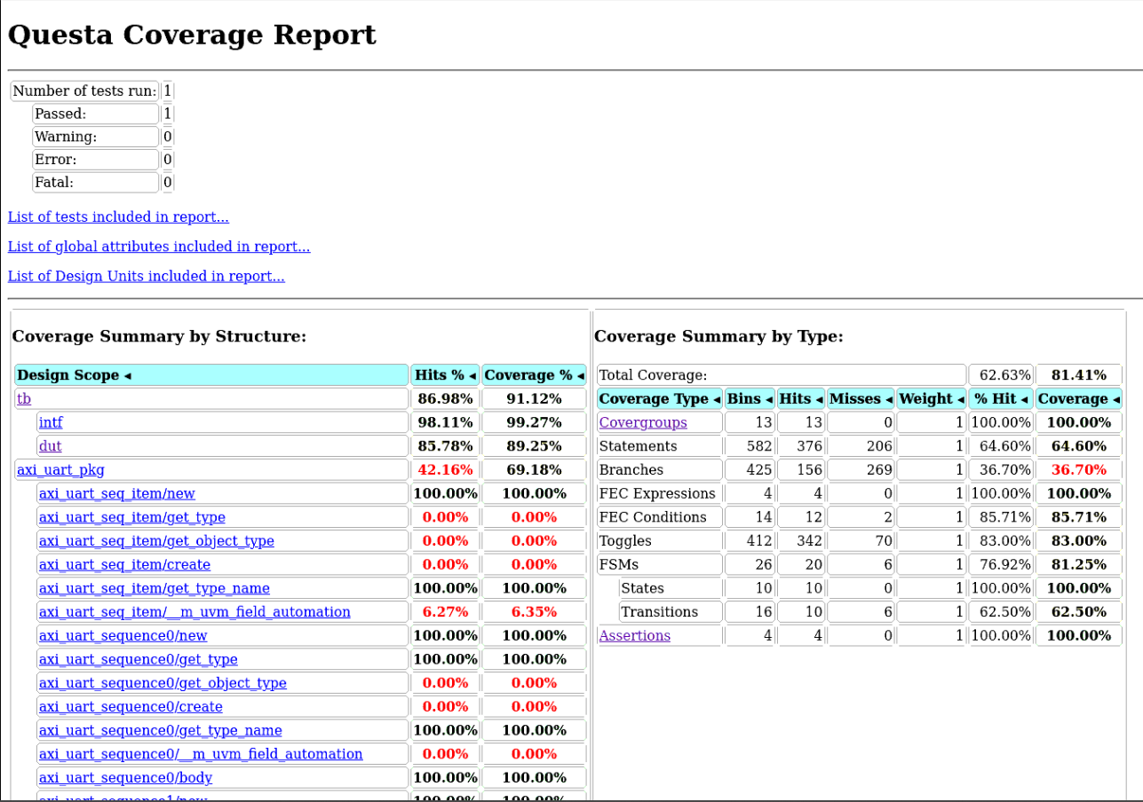

  - Code Coverage After Exclusion
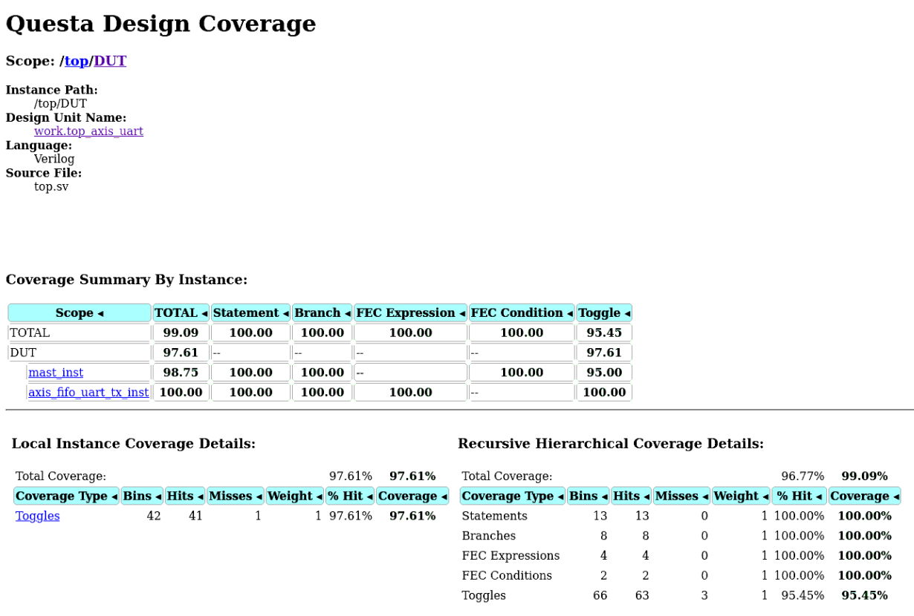
  - What did we exclude and why ?
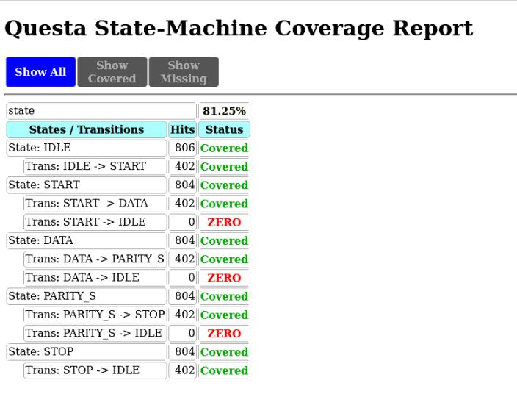

- Here we have excluded the uart_rec_inst module because this module was having the state transitions i.e. DATA->IDLE, PARITY->IDLE, START->IDLE.
- This was not hit because it was not feasible to calculate the time of each bit change of the serial uart_rx and pass the reset at that point of time, if we try to do this it will hinder the transaction and remove all the previous stream of data.
- So we excluded the module to achieve this coverage.

- Assertions
Assertion | Description | Status
RESET | While reset is asserted all the ouputs should be 0 except m_axis_ready | PASS
VALIDITY | When valid is asserted high then all data and valid signal should be known | PASS
OUTPUT _AFTER_4774 | When axis_data is present the rx_data should be present after 4774 clock cycles | PASS
Parallel_serial | When RX_DATA is high, the serial data should be present and RX_VALID SHOULD BE HIGH | PASS

CHAPTER – 6
- OUTPUT
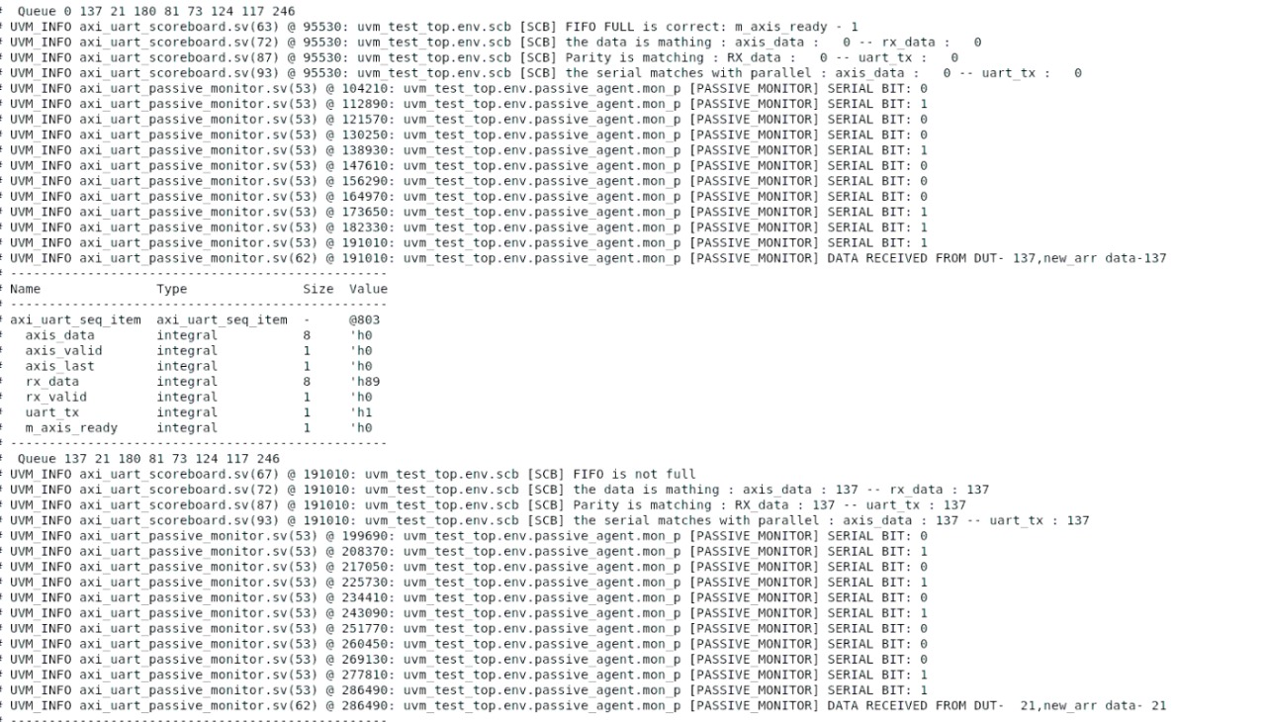
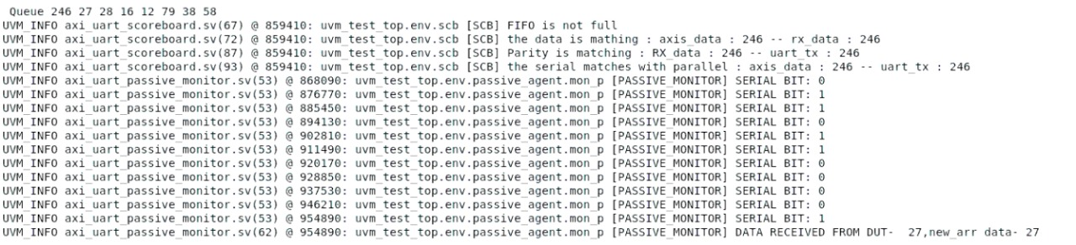
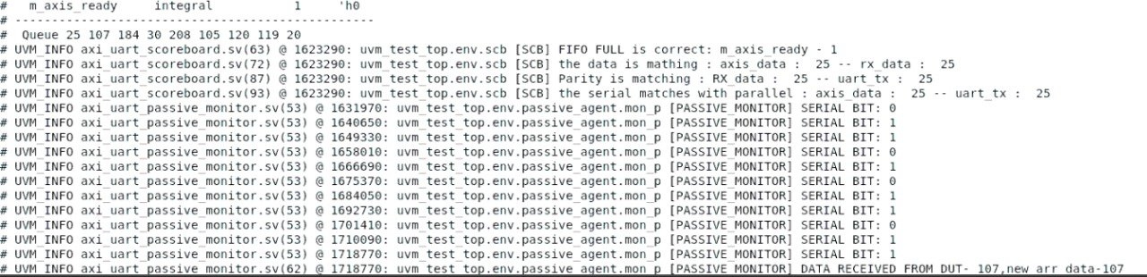

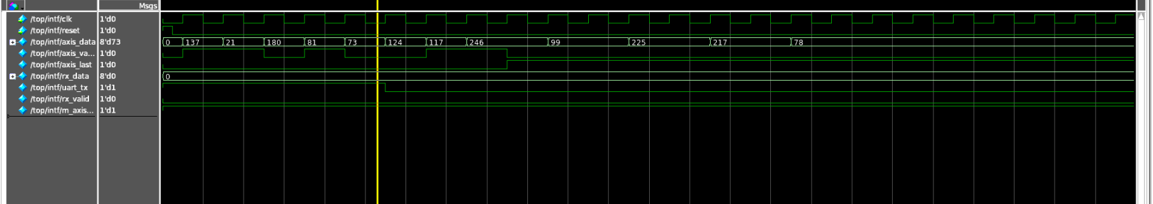

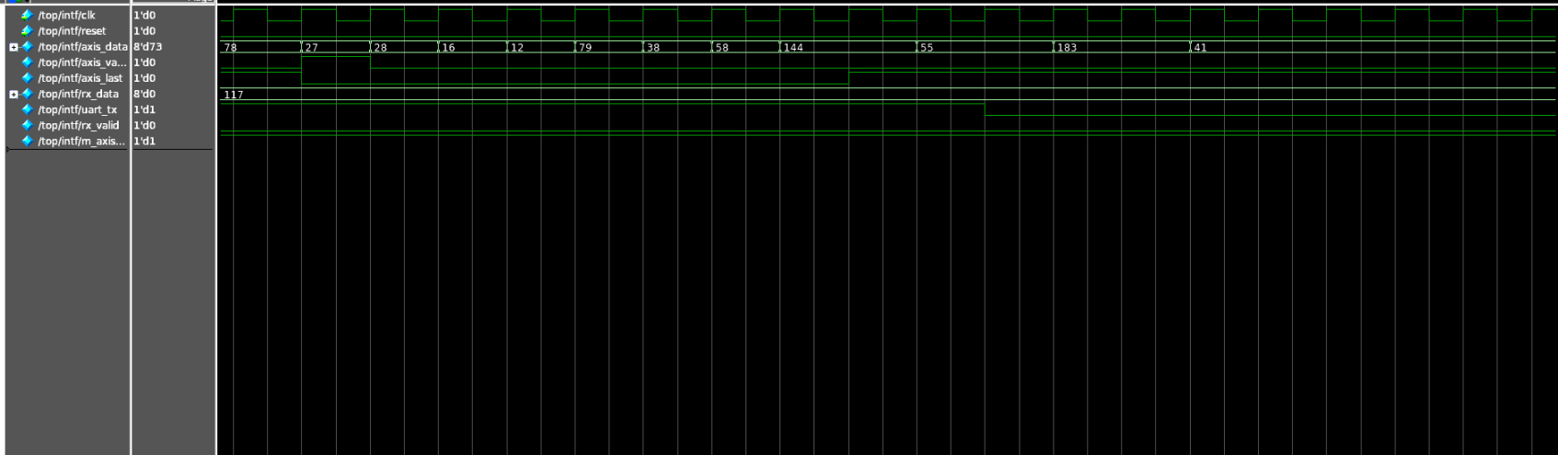

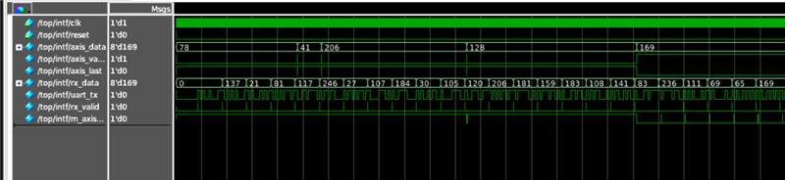

CHAPTER – 7
- Conclusion and Learning
- The AXI-UART verification environment was successfully designed using the Universal Verification Methodology (UVM), ensuring modularity, scalability, and reusability across components.
- The verification flow demonstrated proper interaction between AXI (parallel) and UART (serial) protocols, validating data integrity across transmission and reception paths.
- Active and passive agents were used to monitor and drive signals efficiently, while the scoreboard compared UART TX and RX data to ensure correctness.
- Global variables and synchronization techniques were implemented to maintain timing accuracy during parallel-to-serial conversions.
- Functional coverage and assertions were used to validate corner cases, ensuring robust verification.
- Through this project, key learnings included:
  - Understanding and implementing AXI and UART protocol-level verification.
  - Developing reusable UVM components such as agents, monitors, drivers, and scoreboards.
  - Using configuration databases and analysis ports for data sharing between components.
  - Handling timing-sensitive verification involving baud rate calculations and clock synchronization.
  - Improving debugging and reporting skills using UVM messaging and topology tracing.
Overall, this project provided a strong practical understanding of building a complete UVM-based verification environment, enhancing both technical and conceptual verification skills.

